HELLO KIDS!
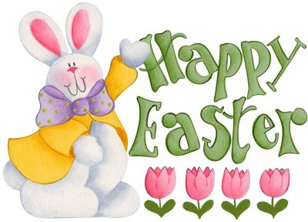

- Watch the video “Easter in Britain” https://www.youtube.com/watch?v=onFF6NVwEeU

- Write the following questions in your exercise book and answer: (sul quaderno, dopo aver scritto come sempre data e tempo atmosferico, scrivi la consegna indicata qui sotto in rosso, le domande sul video (dalla “a” alla “h” ) e rispondi)

How people celebrate Easter in Britain. Answer the questions.
- What festivity is it?
- What’s the girl’s name?
- How old is she?
- What does the girl buy with her father?
- What do children do on Good Friday?
- What does mum prepare for the children to eat?
- Do children go to church on Easter Sunday?
- What do they do after?
- What do children do on Easter Monday?

- Infine, se vuoi, prepara anche tu gli “hot cross buns” seguendo il video e la ricetta allegati https://www.youtube.com/watch?time_continue=48&v=2b68mZm3z1c&feature=emb_logo
Happy Easter!

